**Day-1**

Servers and PCs are connected to the switch.

CISCO catalyst switch : Catalyst 9200 , Catalyst 3650

Router is used to connect the switches between two different LANs or two branches (Tokyo and Newyork)

CISCO router : ISR 1000, ISR 900, ISR 4000

Routers have few network interfaces than switches.

Note: Switches are used to forward data within a LAN. Routers do the opposite. Routers are used to provide connectivity between LANs. Routers are therefore used to send data over the Internet.

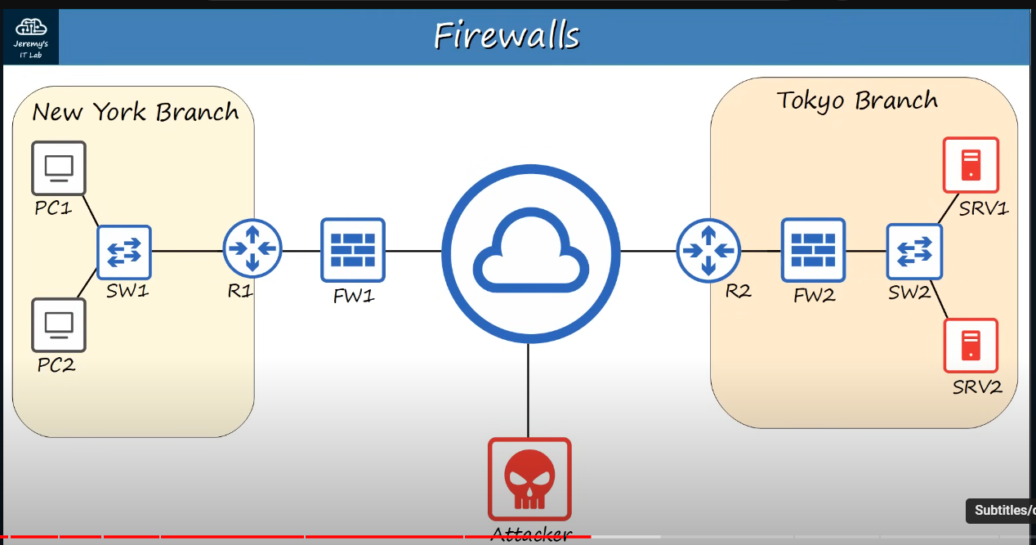

**Networking Firewalls:**

Firewalls are specialty network security devices that control network traffic entering and exiting your network. Firewall can be places outside of your router like FW1, or inside of network like FW2.

CISCO Firewalls : ASA5500-X, Firepower 2100(next generation firewall).

Firewalls monitor and control network traffic based on configured rules.

Firewall are known as “Next-Generation Firewalls” when they include more modern and advanced filtering capabilities.

**Host-Based Firewalls:**

Host-based firewalls are software applications that filter traffic entering and exiting a host machine, like a PC.

**Day-2**

Switches have ports and these ports are also known as Interfaces.

Bits and Bytes

* 1 kilobit (Kb) = 1,000 bits
* 1 megabits (Mb) = 1,000,000 bits
* 1 gigabit (Gb) = 1,000,000,000 bits
* 1 terabit (Tb) = 1,000,000,000,000 bits

Note

* 1 byte = 8 bits

Ethernet Standards (copper)

IEEE 802.3 standards in 1983. Example: 10BASE-T and here T means Twisted Pair Cable.

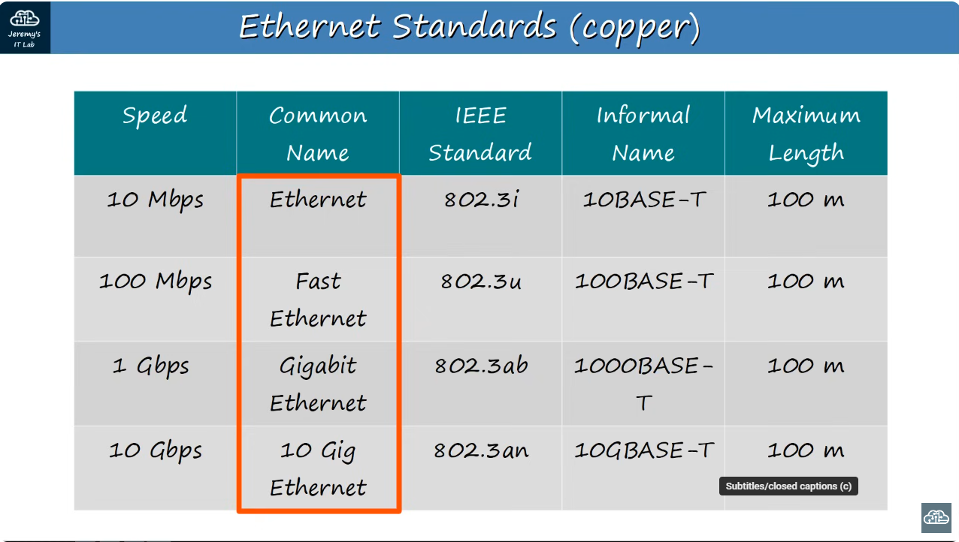

UTP (Unshielded Twisted Pair)

Example RJ-45

Other

10BASE-T

100BASE-T both have 2 pairs or we can say 4 wires.



Duplex means both device can send data at the same time.

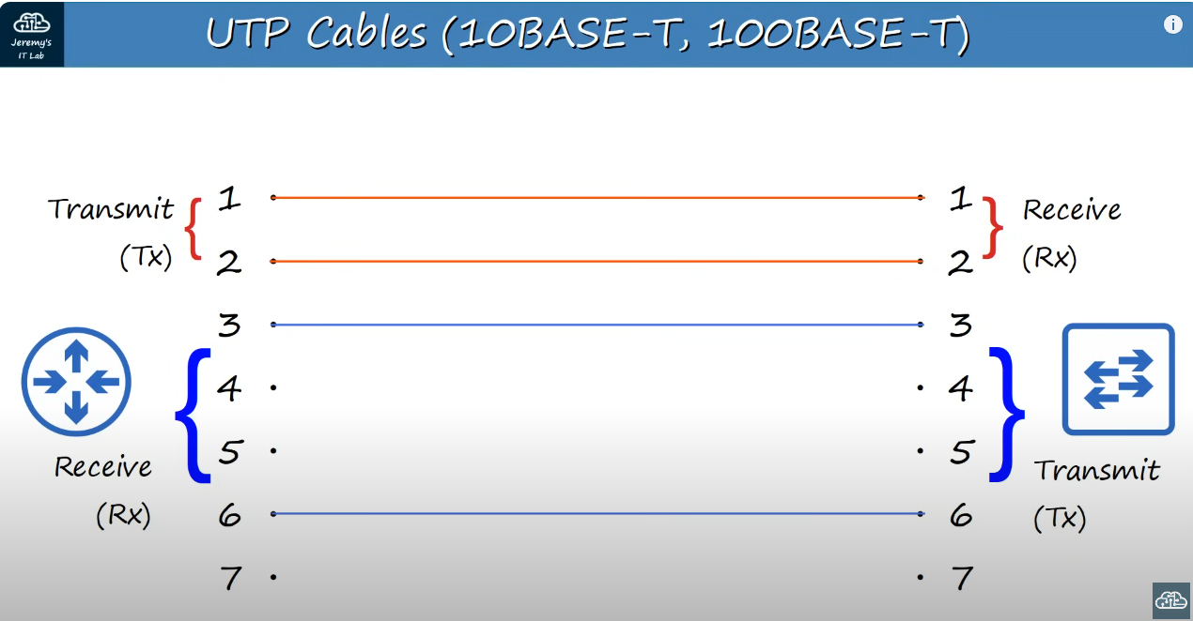

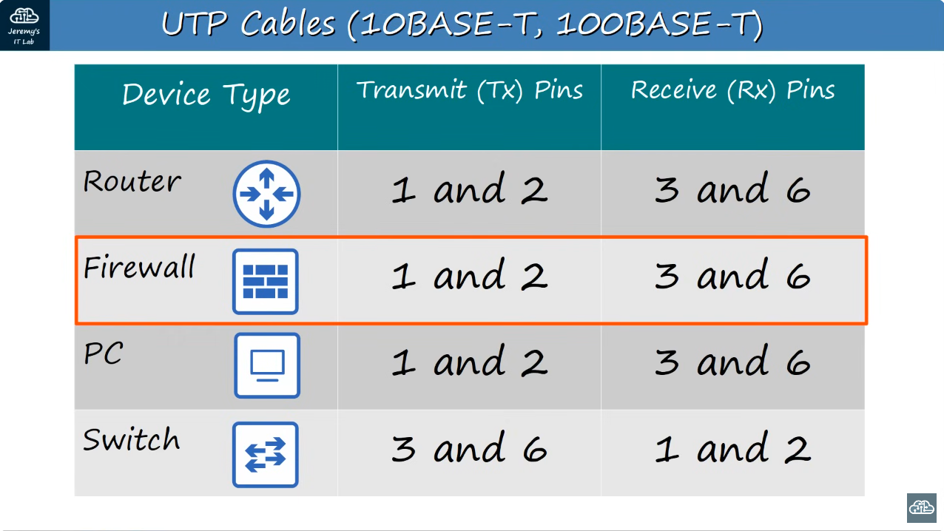

We can see that the if two different end have router and switch then router sends the data from 1 and 2 pin which is received by the switch from pin 1 and 2. Therefore, they needed the straightforward cable.

And when we want to send data between router and pc, then both of them uses 1 and 2 pin for transferring data so we have to do crossover here.

Note: UTP only covers about 100m

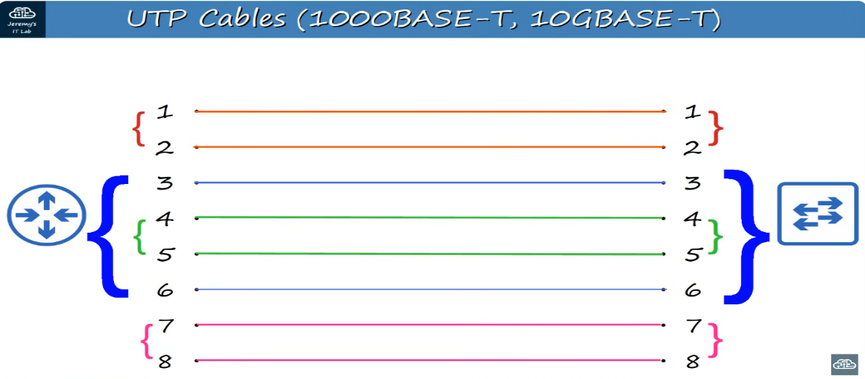

These 8 wires are used for larger networks.

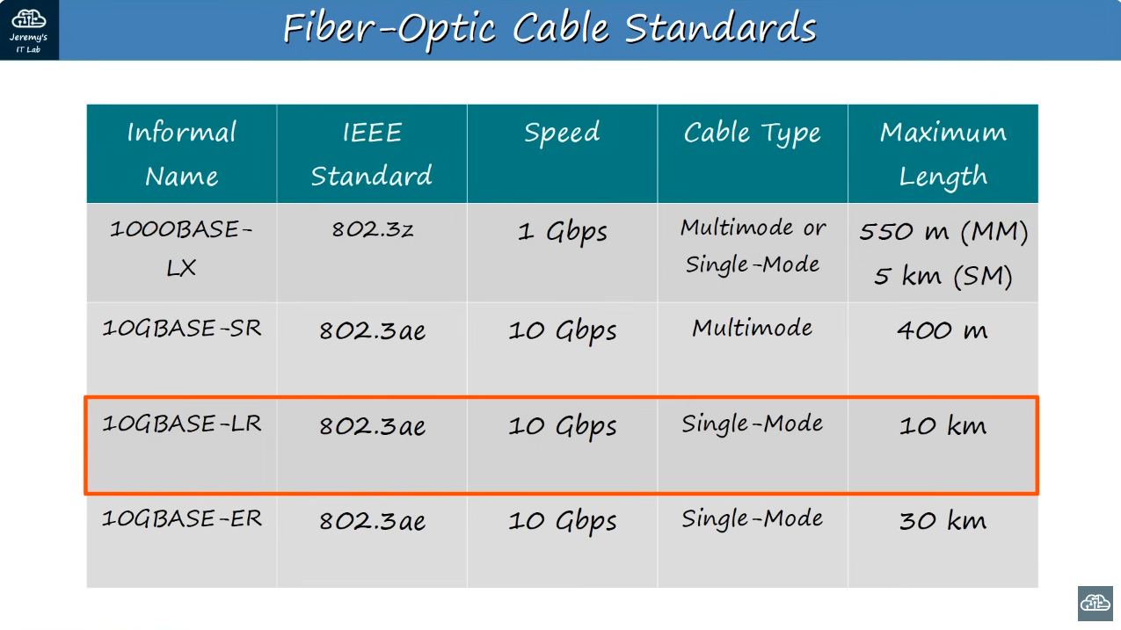

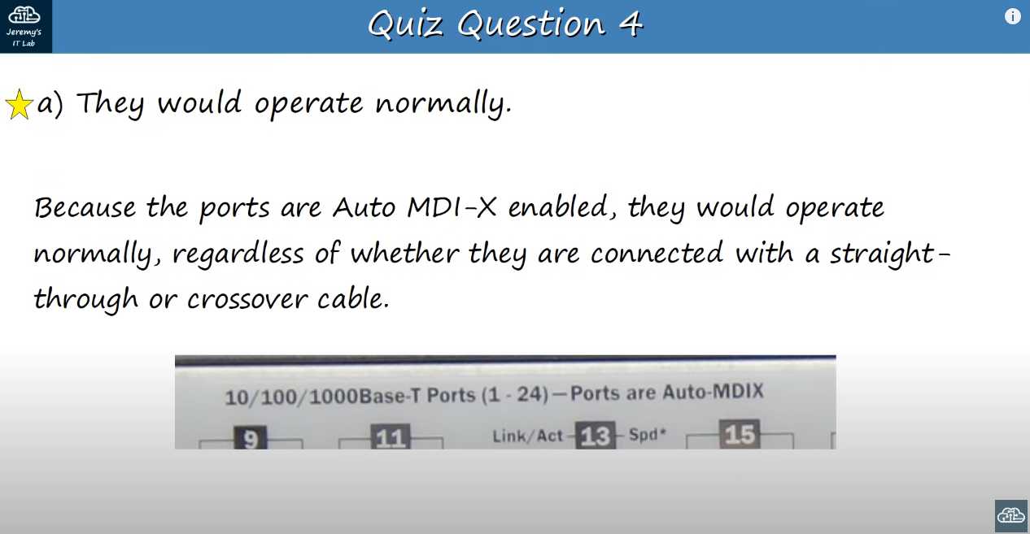

**DAY-3**

A network protocols are the set of rules defining how network devices and software should work.

Networking models categorize and provide a structure for networking protocols and standards.

OSI Model (Open system interconnection)

* Application – Brave, chrome. Http and https are layer 7 protocols.
* Presentation – Its job is to translate between application and network formats. For example, encryption of data as it sent, and decryption of data as it is received.
* Session – Controls session between communicating hosts. Establishes, manages and terminates connections between the local application (for example, web browser) and the remote application (for example, Youtube).
* Transport – Breaks large pieces of data into smaller segments which can be more easily sent over the network and are less likely to cause transmission problems if errors occur. Layer4 header is added to each in the segmented data (smaller pieces).
* Network – Provides connectivity between end hosts on different networks. (outside of LAN). Provides path selection between source and destination. Routers operate at layer 3. Source and Destination IP address are added to the segments and are called packets.
* Data Link – In this the header and trailer (head and tail) are added and is called frame. Provides node-to-node connectivity and data transfer (for example, PC to switch, switch to router, router to router). Defines how data is formatted for transmission over a physical medium (for example, copper UTP cables). Detects and (possibly) corrects Physical Layer errors. Switches operate at layer 2.
* Physical -